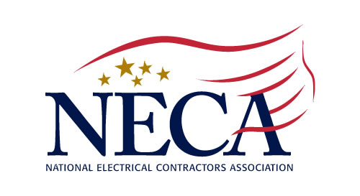
August 2020
Northern New Jersey Chapter, Inc.
213 Summit Road, PO Box 1081, Mountainside, NJ 07092-0081
Tel: (908) 654-5770 Fax: (908) 654-1754
www.necannj.com chapteroffice@nnjneca.com

3 Credit Hours Approved by the Board of Examiners of Electrical Contractors

Business Succession Planning

Instructors - Scott Krim, Jonathan Peters & David Scher of Krim Associates

Reasons to have a plan in place
● Fair value for business ● Minimizing tax liabilities
● Partner death, disability or retirement ● Better defined operational roles

Succession Planning Solutions
● Buy/Sell Agreements ● Setting a fair value price/Certificates of Value
● Cross Purchase Agreements vs Entity Redemption ● Credit Protection

Organizing Financial Records
● Ensuring adequate resources are available in the ● Minimizing exposure to taxes and other fees
event of disability or death ● Minimizing exposure to creditors/other liabilities
● Deciding who takes what, when, and how much ● The power of compounding
● Ensuring adequate liquidity is available for a family ● What has history taught us about asset allocation
business (and in many cases, ensure that all family strategies
members are treated fairly).

● Stocks ● Dividends ● Real Estate ● Retirement Options/Deferred Comp Solutions
● Alternative Investments ● 401K/Profit Sharing/Defined Benefit Plans
● The Importance of Diversification ● Understanding Volatility
VIRTUAL PRESENTATION

October 6, 2020 1:00-4:00 PM

COST: NECA Members Free $40 Non-NECA Contractors
_____________________________________________________________________________________________________________________________________________________________________

Business Succession Planning - October 6, 2020 - Virtual Platform
(As it appears on your electrical license)

Name ________________________________________ License # _________________ Cell ________________________

Name ________________________________________ License # _________________ Cell ________________________

Company __________________________________________________________________________________________

Billing Address & Telephone ___________________________________________________________________________

Credit Card: □ AmEx □ MasterCard □ VISA Expiration ______________ Security # ______________

Credit Card # _______________________________________________ Amount to be Charged _______________

Name on Card _____________________________________________
Please make check payable to:
Northern New Jersey Chapter, NECA
PO Box 1081, Mountainside, NJ 07092

Signature ___________________________________________________

Email Address _____________________________________________

