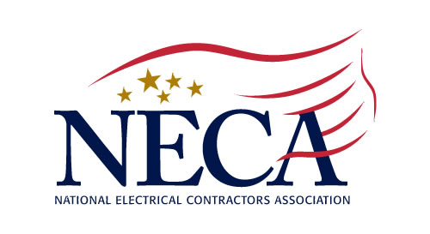
August 2020
Northern New Jersey Chapter, Inc.
213 Summit Road, PO Box 1081, Mountainside, NJ 07092-0081
Tel: (908) 654-5770 Fax: (908) 654-1754
www.necannj.com chapteroffice@nnjneca.com

2 Credit Hours Approved by the Board of Examiners of Electrical Contractors

Executive & Deferred Compensation
and Employee Retention

Instructors - Scott Krim, Jonathan Peters & David Scher of Krim Associates

Discussion of Compensation Plans Executive Bonus – Section 162 Bonus Plans
● 409A Deferred Compensation Plan ● Deductibility
● Loan Regime Split Dollar ● Cost effectiveness for employee/employer
● Executive Bonus 162 ● Ways to create supplemental income

Split Dollar SERP
● How they work ● Ways it can supplement retirement income
● Benefits to employer ● Objective of SERPS -retain, reward, recruit
● Impact to financials ● Types of SERPS (defined benefits v defined
● Long-term benefits to employee contribution)

VIRTUAL PRESENTATION

October 20, 2020 1:00-3:00 PM

COST: NECA Members Free $30 Non-NECA Contractors

4________________________________________________________________________________________________________________________________________________________________________________________________________________________________________________

Executive & Deferred Compensation and Employee Retention - Oct 20, 2020 - Virtual Platform
(As it appears on your electrical license)

Name ________________________________________ License # _________________ Cell ________________________

Name ________________________________________ License # _________________ Cell ________________________

Company __________________________________________________________________________________________

Billing Address & Telephone ___________________________________________________________________________

Credit Card: □ AmEx □ MasterCard □ VISA Expiration ______________ Security # ______________

Credit Card # _______________________________________________ Amount to be Charged _______________

Name on Card _____________________________________________
Please make check payable to:
Northern New Jersey Chapter, NECA
PO Box 1081, Mountainside, NJ 07092

Signature ___________________________________________________

Email Address _____________________________________________

