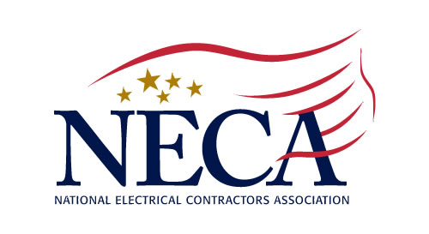
6 CREDIT HOURS Approved by the Board of Examiners of Electrical Contractors August 2020
Northern New Jersey Chapter, Inc.
213 Summit Road, PO Box 1081, Mountainside, NJ 07092-0081
Tel: (908) 654-5770 Fax: (908) 654-1754
www.necannj.com chapteroffice@nnjneca.com

Principles of Job Productivity Assurance & Control

Process and Product based on ASTM Standard E2691 (Construction Productivity Measure)
Dr. Heather Moore – Instructor

Job productivity has historically been measured from the accounting perspective. This method of measurement has alienated the labor; as a result the outcome is data that is not useful. This course will teach the principle, exercised successfully by other industries, of measuring productivity from the operator’s point of view. The participant will learn how to establish a useful productivity measuring method. This will help them to improve productivity by making it more visible.

JPAC® is the direct application of Statistical Process Control (SPC) to projects. Just like SPC, JPAC® will establish the baseline of job productivity and, at regular intervals, control and assure the adherence to project goals. Project goals are broken down into control elements, which will be monitored by JPAC®. Control elements are such items as:

1. Labor 2. Change Order 3. Overtime 4. Schedule 5. Estimate 6. Material Handling and Procurement

Using the existing processes, software and information technology tools, JPAC® will extract data from the accounting, project management, inventory management and other areas of the organization and create trend monitoring graphs. The total process capabilities will be monitored and reported. JPAC® is based on the “fix as you go” philosophy of operation, which will reduce the cost of repairs and decrease surprises at the end of the job.

An additional function of JPAC® is “End of the Job” cost and profit prediction. Using JPAC®’s forecast, the “Work In progress” (WIP) can be accurately calculated and earned revenues realized. This will allow the organization to have better cash flow and profit prediction. The application of JPAC® to jobs will guarantee much higher profits and better cash flow. JPAC® will also help increase the job estimate accuracy and hit-ratios.

The seminar is based on research conducted by MCA for the construction industry.

September 17-18, 2020
VIRTUAL PRESENTATION
1:00-4:00 PM each day

COST: $50 (NECA Members) $125 (non-NECA Union Contractors) non-refundable

Principles of Job Productivity Assurance & Control ● September 17-18, 2020 ● Virtual Platform

(Print name as it appears on your electrical license)

Name ________________________________________ License # __________________ Cell ____________________

Name ________________________________________ License # __________________ Cell ____________________

Firm Name __________________________________________________________ Tel __________________________
□ AmEx □ MC □ VISA Credit Card # ______________________________ Exp ___________ Security # __________
Name on Card _______________________________________ Signature _______________________________________
Billing Address ______________________________________________________________________________________
Email ______________________________________________________________ Amount to be Charged ____________

Please make check payable to: Northern New Jersey Chapter, NECA, PO Box 1081, Mountainside, NJ 07092

