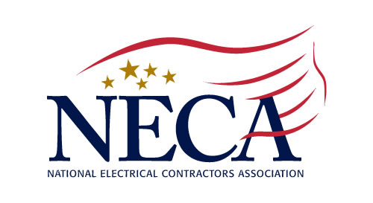
August 2020
Northern New Jersey Chapter, Inc.
213 Summit Road, PO Box 1081, Mountainside, NJ 07092-0081
Tel: (908) 654-5770 Fax: (908) 654-1754
www.necannj.com chapteroffice@nnjneca.com

6 CREDIT HOURS Approved by the Board of Examiners of Electrical Contractors

How to Implement
Short Interval Scheduling (SIS®)
(using ASTM Standard E2691) Dr. Heather Moore, Instructor
______________________________________________________________________________________________________________________________________________________________________________________________________________________________________________________

Labor management is the highest risk in Contracting. Most of the issues that labor faces in their daily work are hidden from management. With 3-day scheduling all these issues become visible and project management and management of the company can improve on them to improve job productivity.

The participants will learn hands-on, the simple methods and tools that can be used to schedule their jobs, and how to identify the obstacles and reduce labor waste which can improve job productivity by better than 30%.

Each of the following items will be introduced, explained, and applied within the course to allow the Participants to tie their in-course progress to the learning objectives:
VIRTUAL
PRESENTATION
1. Impact of scheduling on their job productivity
2. Tracking forms for 3-day schedule, and hands-on
creation of tracking forms
3. Charting of the data
4. Analysis and interpretation of the charts

The creation of the data analysis tools will be judged against correct usage of the statistical tool and the Participants will be tested on what they will do with the analysis once they have correctly designed the data analysis tools.

November 5-6, 2020 1:00-4:00 PM each day

COST: $50 (NECA Members) $125 (non-NECA Union Contractors) non-refundable

How to Implement Short Interval Scheduling ● November 5-6, 2020 ● Virtual Platform

(Print name as it appears on your electrical license)

Name ________________________________________ License # __________________ Cell ____________________

Name ________________________________________ License # __________________ Cell ____________________

Firm Name __________________________________________________________ Tel ___________________________
□ AmEx □ MC □ VISA Credit Card # _________________________________ Exp __________ Security # __________
Name on Card _______________________________________ Signature _______________________________________
Billing Address ______________________________________________________________________________________
Email ______________________________________________________________ Amount to be Charged ____________

Please make check payable to: Northern New Jersey Chapter, NECA, PO Box 1081, Mountainside, NJ 07092

